IA 1 QUESTIONS :

1.compare 2 3 4 variable karnaugh map?

The Karnaugh Map also called as K Map is a graphical representation

that provides a systematic method for simplifying the boolean expressions.

**Two Variable K Map-**

* Two variable K Map is drawn for a boolean expression consisting of two variables.
* The number of cells present in two variable K Map = 22 = 4 cells.
* So, for a boolean function consisting of two variables, we draw a 2 x 2 K Map.

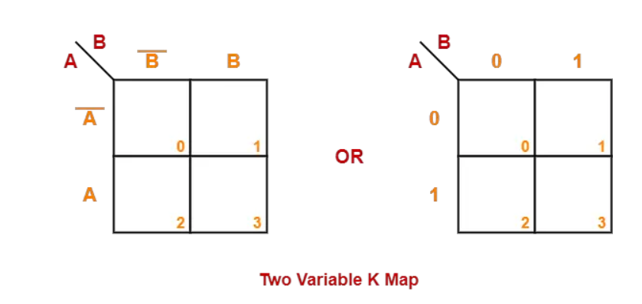

**Three Variable K Map-**

* Three variable K Map is drawn for a boolean expression consisting of three variables.
* The number of cells present in three variable K Map = 23 = 8 cells.
* So, for a boolean function consisting of three variables, we draw a 2 x 4 K Map.

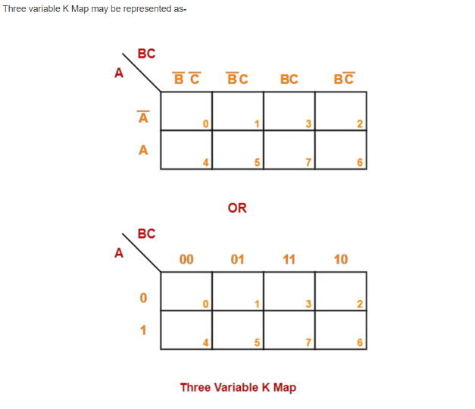

### ****Four Variable K Map-****

* Four variable K Map is drawn for a boolean expression consisting of four variables.
* The number of cells present in four variable K Map = 24 = 16 cells.
* So, for a boolean function consisting of four variables, we draw a 4 x 4 K Map.

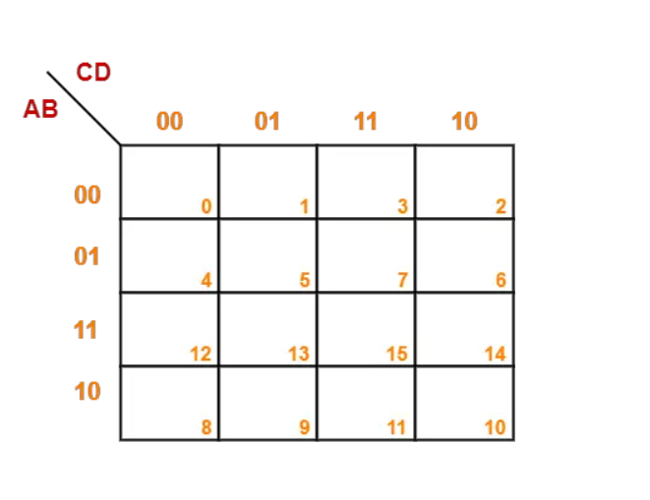Four variable K Map may be represented as-

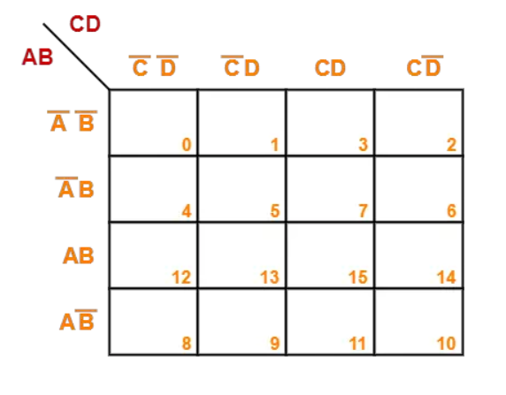

2. Solve the Sum of Product terms F(a,b,c) =∑ (1,3,4,5,6,7).

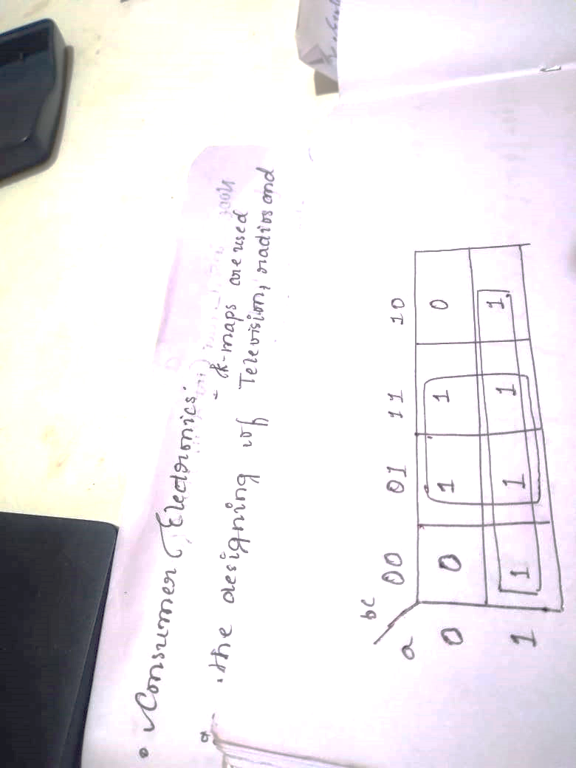

F=a + c

3. Explain in essential features of the Karnaugh’s Map?

Some of the essential features of k map include:

1. Digital Circuits: Karnaugh maps are widely used in the design of digital circuits. The simplified expressions obtained from K-Maps can be easily translated into logic gates, making it easier to design and implement the circuit.
2. Computer memory: K-Maps are used in the design of computer memory. The simplified expressions obtained from K-Maps help in reducing the size and complexity of the memory circuit.
3. Communication systems: K-Maps are used in the design of communication systems. The simplified expressions obtained from K-Maps help in reducing the complexity and improving the efficiency of the communication system.
4. Consumer electronics: K-Maps are used in the design of consumer electronics such as televisions, radios, and other electronic devices. The simplified expressions obtained from K-Maps help in reducing the size and complexity of electronic devices.
5. Automotive electronics: K-Maps are used in the design of automotive electronics such as engine control units, braking systems, and other electronic systems. The simplified expressions obtained from K-Maps help in reducing the size and complexity of the electronic systems, making them more efficient and reliable.

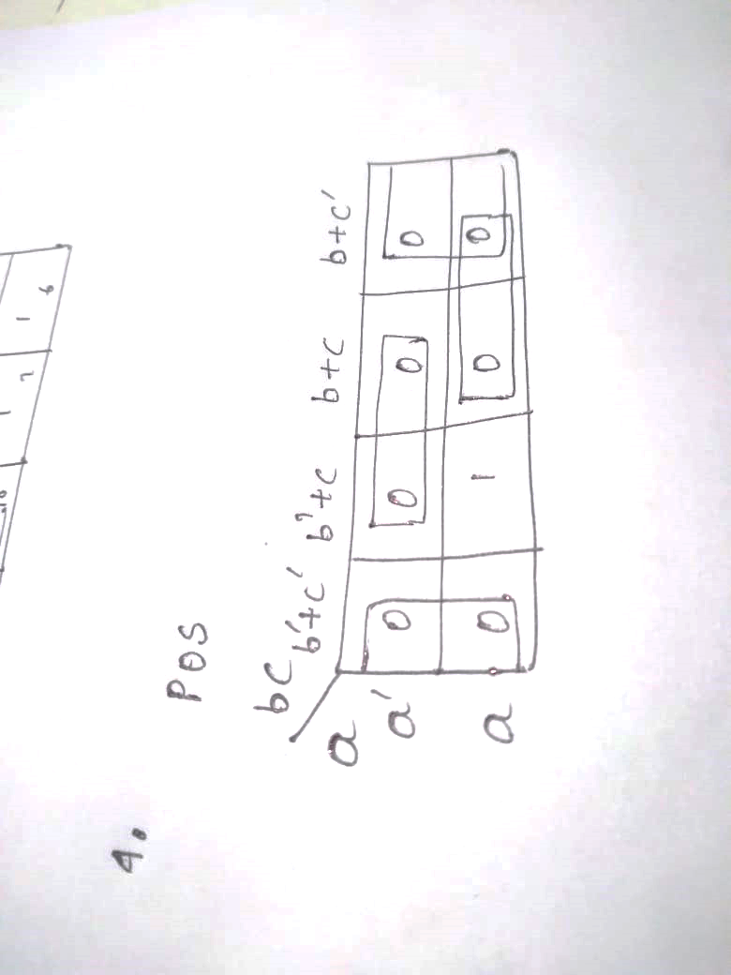

4. Solve Product of Sum terms F(a,b,c) =∑ (0,1,2,3,4,6,7)

F=c’.(a”+c).(a+b)

F=

5.Solve the Product of Sum terms F(a,b,c) = π (1,4,5).

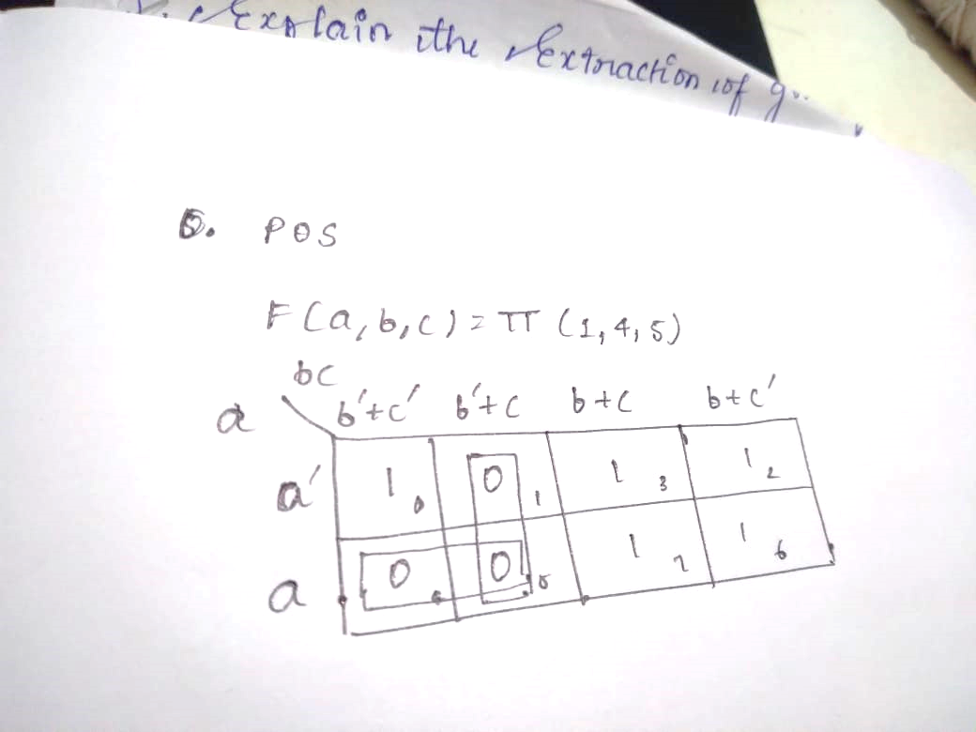

=F(a+b’).(b’+c)